**DAILY ONLINE ACTIVITIES SUMMARY**

|  |  |  |  |  |  |  |  |  |
| --- | --- | --- | --- | --- | --- | --- | --- | --- |
| **Date:** | **14/06/2020** | | | | | **Name:** | **NAIPUNYA VINOD NAIK** | |
| **Sem & Sec** | **IV SEM & A SECTION** | | | | | **USN:** | **4AL18CS050** | |
| **Online Test Summary** | | | | | | | | |
| **Subject** | | **N/A** | | | | | | |
| **Max. Marks** | | **N/A** | | **Score** | | | **N/A** | |
| **Certification Course Summary** | | | | | | | | |
| **Course** | **INTRODUCTION TO PROGRAMMING** | | | | | | | |
| **Certificate Provider** | | | **GREAT**  **LEARNING**  **ACADEMY** | | **Duration** | | | **5 HRS** |
| **Coding Challenges** | | | | | | | | |
| **Problem Statement:1)** [Write a C program to remove specific characters in the String](https://github.com/orgs/alvas-education-foundation/teams/2nd-year/discussions/117). | | | | | | | | |
| **Status:EXECUTED** | | | | | | | | |
| **Uploaded the report in Github** | | | | | **YES** | | | |
| **If yes Repository name** | | | | | <https://github.com/naipunya-naik/lockdown-coding/blob/master/C%20CODING/removechar_14-06-2020.c> | | | |
| **Uploaded the report in slack** | | | | | **YES** | | | |

Online Test Details: (Attach the snapshot and briefly write the report for the same).

NO INTERNALS

Certification Course Details: (Attach the snapshot and briefly write the report for the same)

CERTIFICATION COURSE NAME :- INTRODUCTION TO PROGRAMMING

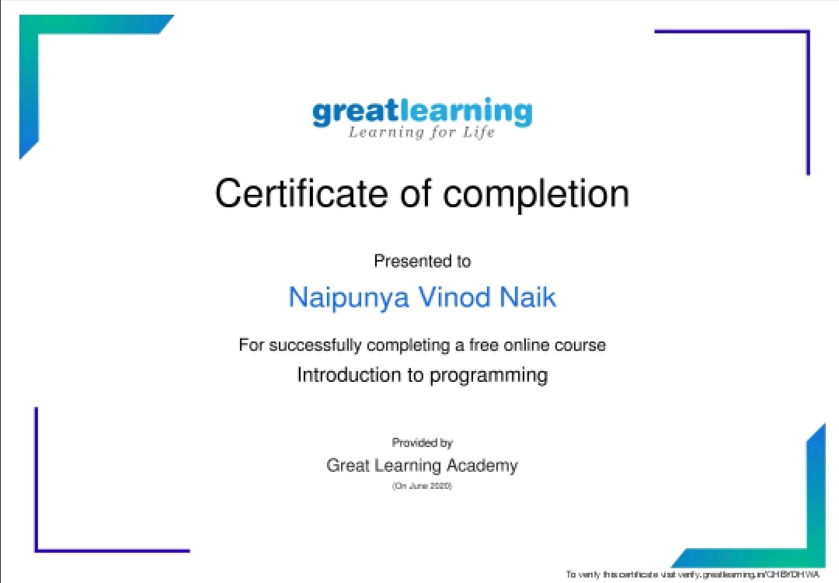

TODAY I COMPLETED AN ENTIRE COURSE ON INTRODUCTION TO PROGRAMMING.

Coding Challenges Details: (Attach the snapshot and briefly write the report for the same).

PROBLEM STATEMENT :-

[Write a C program to remove specific characters in the String](https://github.com/orgs/alvas-education-foundation/teams/2nd-year/discussions/117).

Top of Form

Bottom of Form

|  |
| --- |
| Example If the original string is "Welcome to AIET" and the user inputs string to remove "co" then the it should print "Welme to AIET" as output .  **Input** First line read a string Second line read key character to be removed.  **Output** String which doesn't contain key character |

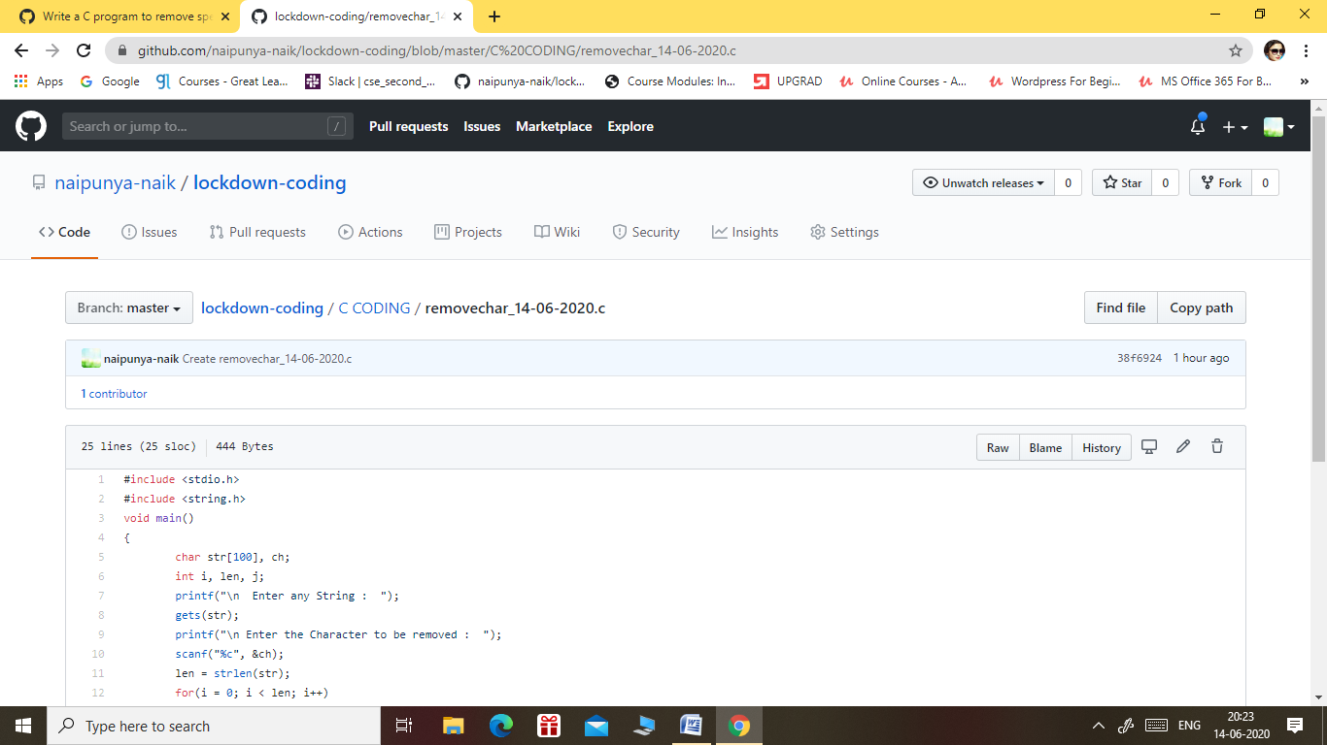

GITHUB REPOSITORY LINK:-

<https://github.com/naipunya-naik/lockdown-coding/blob/master/C%20CODING/removechar_14-06-2020.c>